K-12 SKIP-A-THON – May 28th at Noon for Mrs. Grant
We would like to support Mrs. Grant. Students & staff can get pledges or get donations from their families if they wish. Please remember K-5 students should not go door to door for safety reasons. All students regardless of donations are invited to join us at noon in support of Mrs. Grant for a half hour of skipping!

“Thank you” to our friends at Sabian for sponsoring our “free salad bar.” It was enjoyed by all!

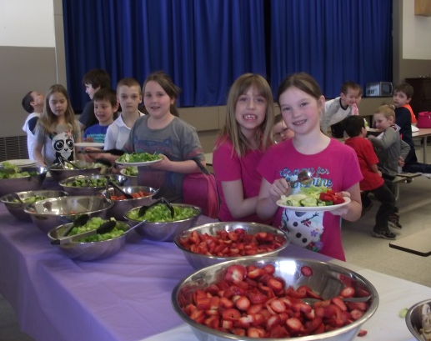
April 2015 Cafeteria Menu
Tues | Wed | Thurs | Fri
31  Ham & French Toast or Pancakes, orange slices | 1  Chinese Plate  Rice, eggroll, honey garlic meat balls, stir fry | 2  Pizza Day  Regular, barbeque chicken or veggie | 3  Good Friday  No School
7  Subs served with Seasoned Potato Wedges | 8  Chicken & Veggies in gravy served on a biscuit | 9  Pizza Day  Regular, barbeque chicken or veggie | 10  No School  Parent Teacher AM  CD day PM
14  Lasagna & Cesar Salad | 15  Pork roast with potatoes and veggies | Chicken Fajita 16  & Seasoned Potato Wedges | 17  Pizza Day  Regular or Veggie Pizza
21  Beef Stir Fry, Rice, & veggies | 22  Orange Ginger Chicken & Rice or | 23  Bacon Wrapped Barbecue Chicken, Potatoes, Veggies | 24  Pizza Day  Regular, Hawaiian or veggie pizza
28  Shake & Bake Chicken, potatoes, veggies | 29  Hawaiian Pineapple Chicken, potatoes, Veggies | 30  Pizza Day  Regular, Hawaiian, Veggie or BBQ chicken | May 1  No School  Professional Development Day
May 2015
Tues | Wed | Thurs | Fri
5  Quiche & Homefries, fruit | 6  No Cafeteria  (Dessert Theatre) | 7  No Cafeteria  (Dessert Theatre) | Pizza Day 8  Regular, barbeque chicken or veggie
12  No Cafeteria | 13  Beef & Veggie Stir Fry served on rice | 14  Spaghetti & Garlic Bread, Caesar Salad | 15  Pizza Day Hawaiian, regular, veggie, Meal
19  Hawaiian Chicken, Rice, Veggies | 20  Breakfast  Meat, eggs, pancakes | 21  Barbeque Items | 22  Pizza Day Hawaiian, regular, veggie, Meal
26  Barbeque Items | 27  French Toast & Ham | 28  Barbeque Items | 29  Pizza Day Hawaiian, regular, veggie, Meal

